
2013-14
Annual Report
Gramin Vikas evam Paryavaran Sanstha
(GVePS)
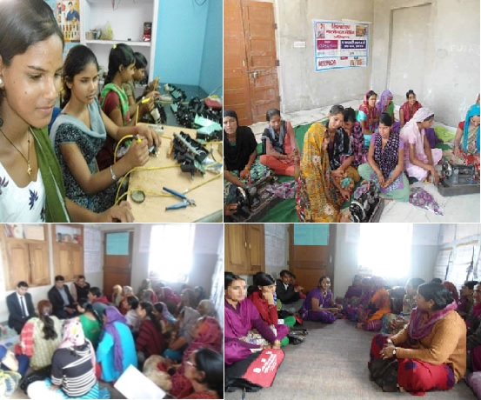

From Directors Desk
Dear Friends,
I am pleased to present, annual report of Gramin Vikas evam Paryavaran Sanstha (GVePS) (FY 2013-14) for your evaluation. This year has been remarkable for the Organisation in many respects, in reaching out to the most disadvantaged and vulnerable sections of the society the struggle for disadvantaged indigenous people of Rajasthan, it also witnessed a careful review of the impact of these relentless efforts at field level.
This journey which has reached up to national, international organisations and corporate houses today was started with the efforts of small group of people.
GVePS has always believed in making a strategy plan for its developmental interventions. In the years of implementation GVePS has not take a project based approach and always believed in need based interventions. GVePS has also developed a detailed Strategic-Plan for another decade and re-aligned its priorities with these underlying values.
I would like to thank all the partner organisations such as Rajasthan State AIDS Control Society, Functional Vocational Training and Research Society and CUTS International and other persons donors for providing us the financial support. I would like to thank all persons and groups who have provided their technical support in carrying out various efforts at the grassroots. This journey of GVePS was not possible without the contribution of intervention community, community based organisations, volunteers, grassroots team members, development professionals and most importantly the well wishers. I would like to express my sincere gratitude to the executive board for their faith in me and for an opportunity to present the annual report.
Your's
Hari Shankar Sharma, Secretary
Sr No | Particulars
1 | From the secretary desk
2 | Snap shot of the organization
3 | Development Interventions
4 | Health
5 | Targeted Intervention HIV/AIDS in Sikar District
6 | Targeted Intervention with MSM in Jaipur
7 | Sexual Reproductive Health and HIV
8 | Income Generation Activities
9 | Skill building programme for livelihood generation
10 | Environment
11 | National Awareness Campaign
12 | Financial Statements

Snapshot of the organisation

Introduction:
Gramin Vikas Evam Paryavaran Sanstha (GVePS) is a voluntary organisation based in Dausa, which works with democratic systems learns, teaches and promotes development. This organisation promotes development programme in partnership and democratic ways, and learns to face challenges in the local areas. In this direction the group provides an opportunity to learn from knowledge, experience, skill of each other and supports in development. The organisation was established in the year 1990 by excited and hardworking youth with the objective of rural development.
Chief Functionary:
Mr Hari Shankar Sharma –
Secretary,
Gramin Vikas evam ParyavaranSanstha.
Intervention Area:
In the districts of Dausa, Sikar and Jaipur districts of Rajasthan State.

Vision:
“GVePS envisions a society that is self sufficient and empowered enough to take care of its developmental needs.”

Mission:
“Provide health, education, environmental and livelihood support to the marginalized population by involving local communities to sustain the development initiatives.

CORE VALUE:
- Integrity
- Determination
- Equality
- Ethical
- Nurturing
- Togetherness

STRATEGIES:
- Awareness Generation on issues of common interest
- Institutional Building- Building institution on social process
- Capacity Enhancement – Building capacity on the individual and group level
- Enhancing knowledge Base of local communities- Enhancing knowledge of the society to make them self sustainable and empowered.
- Public Advocacy- Giving voices to the community by providing a strong base and building strategy for promoting the same.
- Development Action- As per the demands of the society, implementing the developmental work with community participation.
- Similar opportunities- Promoting gender balance.
OBJECTIVES :
- To raise socio-economic status of partner communities through facilitating participatory processes for better management of natural resources and building capacities of community to sustain such processes.
- To design and implement programs aiming at enhancement of livelihood opportunities.
- Facilitating women empowerment processes through gender sensitization and income generation initiatives.
- To undertake specific interventions for promotion and protection of common property resources.
- To adapt popular knowledge in our thoughts and actions. Building capacities of local communities to empower them to participate in the initiatives related to management of natural resource management.
- Providing leadership training and other capacity building inputs to the rural women, for building their capacities in the direction of decision making and self sufficiency
- Involve appropriate actions towards raising the educational and health status of women and children so that they are well placed in development processes
- To develop community based institutions.

Development Interventions:
Health:
Targeted intervention with FSW and MSM in Sikar district:
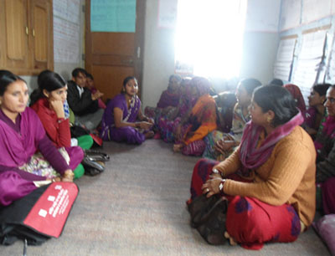
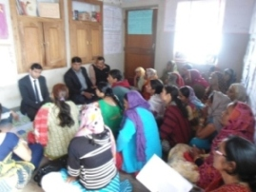
With the objective to raise awareness and prevention of HIV/ AIDS in selected districts of Rajasthan; a programme Targeted intervention was initiated by Rajasthan State AIDS control Society in the year 2005. GVePS with the support of Rajasthan State AIDS control Society, under the, Targeted Intervention initiated a programme in the Sikar district for Female Sex Worker (FSW) and Male Sex having with Male (MSM).

Since 2005, the organisation is successfully implementing the Targeted Intervention programme, as per the achievements of the previous years the organisation is selected and intervention areas is developed as a learning site. In the current year various NGO’s associated with the project of Target Intervention in Rajasthan implemented on the learning’s and best practices followed by GVePS. Shri Niraj K Pawan (IAS) – Director of National Rural Health Mission visited GVePS with objective to review and understand the achievements of GVePS. In the next year the programme will achieve a decade of its successful implementation. In the current year the organisation has a target of 300 FSW and 200 MSW. With the arduous efforts of GVePS there is a steep decline in the AIDS patient and awareness is created in the Sikar district of Rajasthan.
As a part of the programme the organisation has conducted IEC activities like condom promotion, identification of AIDS patient, cure, identification of Sexually Transmitting Diseases (STD’s) and their cure. The organisation provides facilities for regular investigations of FSW and MSW providing them medical and legal advice. The organisation in the current year with the IEC material promoted 3 types of stickers, use of condom and published a brochure on the men and women sexually transmitting diseases. In the current year with the success of the project Rajasthan State Aids Control Society has also provided a project of Target Intervention in the Jaipur district along with the interventions of MSM.
Targeted Intervention with MSM in Jaipur:
As per the assumptions there are around 1000 to 1500 Male having sex with male (MSM) in Jaipur district. Rajasthan State Aids Control Society, with the Target Intervention project in the month of March has given a target to identify 800 MSM. The organisation for the prevention of HIV/AIDS after the identification of MSM; also register them in records. After the identification, registration, their counseling is done, MSM are taken to ICTC for regular checkup and providing awareness on safe sex. The MSM are also provided awareness on safe sex and enhancing the use of condom. In the month of March mapping and need assessment is done by the survey team. This will be completed by April 2014.
Sexual Reproductive Health and HIV/AIDS awareness programme:
In the Sikar district of Rajasthan the, Target Intervention project is a synonym of Female Sex Worker (FSW) and Male Sex having with Male (MSM). In the financial year with the objective of capacity building in Sexual Reproductive Health and HIV/AIDS programme was initiated.
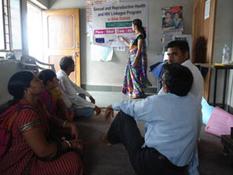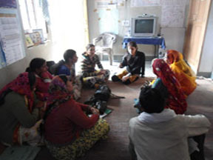
The programme is implemented with 10 Angawadi centers in the Sikar city. During the implementation of the programme women are given awareness on Sexual reproductive health and HIV/AIDS. In the above programme the organisation creates awareness on sexual reproductive health, HIV/AIDS to the women and men partners, provides counseling and cure. They are also given information on vaccination of children and care of pregnant women.

Income Generation Activities:
Skill building programme for livelihood generation in rural areas of Dausa district in Rajasthan:
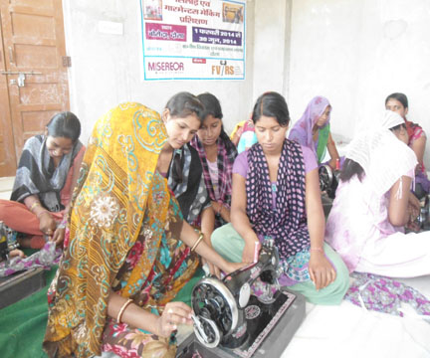
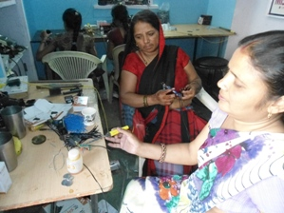
In the rural areas of Dausa district with the objective of capacity and skill building of disadvantaged youth who has never been to school or are school dropout, a project was initiated in partnership with Functional Vocational Training and Research Society for the second time. The project aims at providing skill development for the youth who are in the age of 18-35 years.
Functional Vocational Training and Research Society (FVTRS) as per the experience understands that youth in the age group of 18-35 years in the absence of skill development opportunities work as unskilled labour and are trapped in the vicious cycle of poverty and are often exploited. FVTRS also believes that in this age the youth has extra abilities, during this age if the youth are given right direction and skill training and youth as per their own interest can generate opportunities for themselves, can find job and can also create enterprises for their own.
With the objective of capacity building and skill training to happen at the local levels FVTRS in partnership with Miseror has provided project Since February 2014 to January 2015 for training 110 men and women in the following 3 trades.
- Garments making
- Mobile charger and hands free making
- Basic beautician course for women.
The training happens in 6 batches. During the training an, Entrepreneurship Development Programme was also conducted for 5 days to enhance capacities of the trainees. In the training programme Lead Bank Manager, District Industries Centre, Manager and other persons were invited to build linkages and motivate them to take micro enterprises and self business instead of availing job opportunities for a better future.
Environment
National Environment Awareness Campaign:
With the support Ministry, of Environment and Forest, Government of India, – New Delhi and regional resource agency organizes a National Environment Awareness Campaign with the support of NGO’s. The programme is supported through a Regional Resource Agency; in the state of Rajasthan, the work is supported through ‘CUTS International’’.
Every year an awareness campaign is organized by the Ministry, of Environment and Forest, on a particular theme and works. During the financial year 2013-14 the theme for conducting awareness camp was on ‘Combating Desertification, Land Degradation and Drought’. During the programme a one day programme of 81 farmer women were organized the awareness programme was successfully completed. As a part of the programme slogan writing was done in 10 villages and 20 farmers were provided seeds on improved varieties. We also promote organic farming during the awareness campaign and transfer organic farming technology farmers.

